Материалы международного Интернет проекта ENO

ENO – это международный Интернет- проект, изучающий социальную , природную и культурную среду разных стран мира. Цель проекта - изучение окружающей среды отдельного региона в глобальном аспекте. Участвовать в проекте могут дети 11-17 лет, язык проекта – английский. Координатор проекта – Микка Ванхенен (Финляндия) vanhenen@cc.joensuu.fi
В этом году члены клуба английского языка гимназии №1 г. Дятлово принимали участие в акции по посадке деревьев- символа мира, связи поколений и передачи традиций, посвященной Международному дню мира. В этой акции приняли участие более 650 школ по всему миру.

Международный день мира отмечается в соответствии с резолюцией Генеральной Ассамблеи ООН (2001) как день глобального прекращения огня и отказа от насилия (отмечается ежегодно с 2002 года). Этот день появился в наших календарях в 1982 году по решению Генеральной Ассамблеи ООН (резолюция от 30 ноября 1981 года). Изначально Международный день мира отмечался в третий вторник сентября — день открытия очередной сессии Генеральной Ассамблеи ООН. В резолюции от 7 сентября 2001 года Генеральная Ассамблея постановила, что начиная с 2002 года Международный день мира будет ежегодно отмечаться 21 сентября.

В одном из своих посланий, посвященном Международному дню мира, Генеральный секретарь ООН Кофи Аннан заявил: "Двадцать четыре часа - это немного времени, но достаточно для того, чтобы руководители стран мира начали прислушиваться к голосам своих народов. Некоторые из этих народов хотят положить конец репрессиям и нетерпимости, и они открыто заявили бы об этом, если бы они могли пользоваться своими основными правами и свободами. Другие хотят избавиться от нищеты и отчаяния, и они тоже еще громче заявили бы об этом, если бы они не были столь обременены ежедневной борьбой за добывание пищи и обеспечение крова для своих семей. Руководители должны в первую очередь осознавать значение Международного дня мира . Пусть его идеи находят все более широкий отклик".
После регистрации на сайте проекта мы получили ряд инструкций и указаний, расписание посадки деревьев, приветственную речь, приветственное письмо министра образования Финляндии и всю необходимую информацию для ответного отчета.

ENO TREE PLANTING EVENT
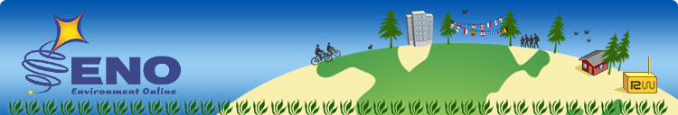
Thursday 21st of September 2006
PREPARATIONS
- Find a tee plant (choose an indigeneous one that is typical for your climate and is one of dominant tree species in your region. Choose a suitable place for tree and dig the hole in advance
- In your class, choose a student who will actually plant this tree.
- Invite a person outside your school to plant tree together with you
- In your class, choose a student who will have a short speech (see below)
- In your class, choose students who will take 2-3 photos (preferably digital) about this occasion.
- Invite other school and local decision-makers to join this event, probably one of them could have a short speech for this occasion.
- At your school, make a map of world with ENO countries involved in tree planting
- Get local media involved (use the draft for them below)
TREE PLANTING EVENT
Date: Thursday, 21st of September
Time: at 12.00-12.30 your local time (or later/before during the day)
- Gather around the tree plant
- A student makes his/her speech
- A student plants this tree together with an old person (while one takes photos, remember to take one photon only about tree, as close as possible)
- Students measure the height of tree (in millimetres)
- Optionally another speech by local decision-makers.
- Other optional program (songs, poems etc.)
- Gather for a group photo, where students and audience are around the tree plant so that we can see BOTH the tree plant AND all the audience
- IMPORTANT :After the event, enter the digital photos and other information to ENO TREE DATABASE with your comments!
- http://eno.joensuu.fi/treedatabase.htm
- After event, share your comments in the SPECIAL CHAT ROOM!
September 2001 the member states of the United Nations unanimously adopted a resolution to establish the UN International Day of Peace, a day of global ceasefire and non-violence, 21 September annually. The Peace One Day film project inspired and documented the creation of the Day and since has been committed to informing the global community of its existence, with a view to manifesting an annual moment of global unity, as Peace Day is envisioned to become. As part of this effort, this year, with your support, we hope to instigate Peace Day activities in all 191 member states of the United Nations in accordance with the resolution.
Peace One Day Objectives:
• To raise global awareness of Peace Day, 21 September annually.
• To engage all sectors of society including governments, organizations of the United Nations system, regional and non-governmental organizations and individuals in the peaceful observance of 21 September through the practical manifestation of non-violence and ceasefire in accordance with UN GA Resolution 55/282.

21 September 2006
Dear virtual learners and teachers,

Planting a tree takes knowledge and skill. But knowledge alone will not make the tree grow; for this you need awareness and enthusiasm to pick up the spade and dig. If the planting goes well and the tree is growing, you have learned the essential and acted on what you have learned. It is quite possible that your children will see the tree you plant now.
Tree planting is motivated by a desire to do good. Seeing "the wood for the tree", we know that our planting has many values. As President Nelson Mandela has said: "Nature may be interpreted in various ways - as a basis for scientific business endeavours; as a resource; something to look at, experience and enjoy; or as an artistic inspiration."
We are currently celebrating the International Decade of Education for Sustainable Development. The essential in sustainable development is to learn to see the various dimensions and consequences that things and actions have. The environment - the state it's in - is interlinked with development, respect of human rights, war and peace, and people's well-being.
The globe is an entity of limited natural resources. We have to learn to save global resources and to share them equally and fairly. During the Decade of Education for Sustainable Development, we should also weigh up different solutions to global problems. Unfortunately, these problems will not disappear or sort themselves out; it is we who need to take action.
Tree-planting is also motivated by a desire to do things together. It is a marvellous feeling to belong to a community of children and young people living in different cultures in different parts of the world, which is, after all, one global village. I think it excellent that you feel shared responsibility and are committed to solving our common problems together.
Thanking you for your initiative, I wish you all the best for the International Day of Peace and success for your virtual network.


Antti Kalliomäki
Minister of Education and Science
Finland

A SPEECH FOR THE OCCASION
Our environment is important for us. Not only locally but also globally around the world. Our school is a member of a programme called ENO-Environment Online. ENO is a global web school for environmental awareness and sustainable development where currently 300 schools in 90 countries study about environment, about physical and social environment, natural environment and ecology, how we could support sustainable development and how we see cultural environment. We are proud and happy to be one of them.
Today is the opening of ENO School year. We plant this tree today, at 12.00 local time, together with our friends in the North, South, East and West. The first trees are planted in Australia. Then, as following the Sun, trees will be planted in Asia, Europe and Africa. Finally they will be put to Earth in the North and South America . Altogether __________ schools in ________ countries are planting trees with us!
This tree is a symbol for us. Firstly, it reminds us of nature and the importance of environmental protection. Secondly, it symbolizes our co-operation between schools around the world, cultural diveristy and tolerance. At the same time, this tree is our contribution for the international day of peace that is celebrated today around the world. We hope this tree to grow together with us, in the future and for the future!
SUGGESTION FOR ADDITIONAL PROGRAM
Sing tree planting songs for the event: (http://eno.joensuu.fi/music/hiandhoe.htm
Forest poems by ENO Students (2001):
http://eno.joensuu.fi/summaries/forestpoems.htm

PRESS RELEASE September 2006

(Your school name) plant trees in a unique global event!
Our school takes part to ENO-Environment Online. ENO programme is a global web school for environmental awareness and sustainable development where currently 300 schools in 90 countries study environmental issues through out the school year on a weekly basis.
September 21st will be the opening of our school year. We celebrate it with planting trees that day, at 12.00 local time, together with schools in the North, South, East and West. The first trees will be planted in Australia. Then following the Sun, trees will spread to Asia, Europe and Africa. Finally trees will be planted in the North and South America.
This tree is a symbol for ENO community . Firstly, it reminds us of the nature and the importance of environmental protection. Secondly, it is a symbol for the co-operation between schools around the world, cultural diversity, tolerance and peace. And above all, 21st of September is the international day of peace! We hope these trees to grow together with us, in the future and for the future.
Registered schools and further information here:
http://eno.joensuu.fi/treeceremony.htm
ENO Programme
http://eno.joensuu.fi
We invite you to participate this event!

Посадив дерево во дворе школы, а эту миссию мы возложили на первых выпускников гимназии нам необходимо было отправить на сайт проекта приветсвенное письмо:

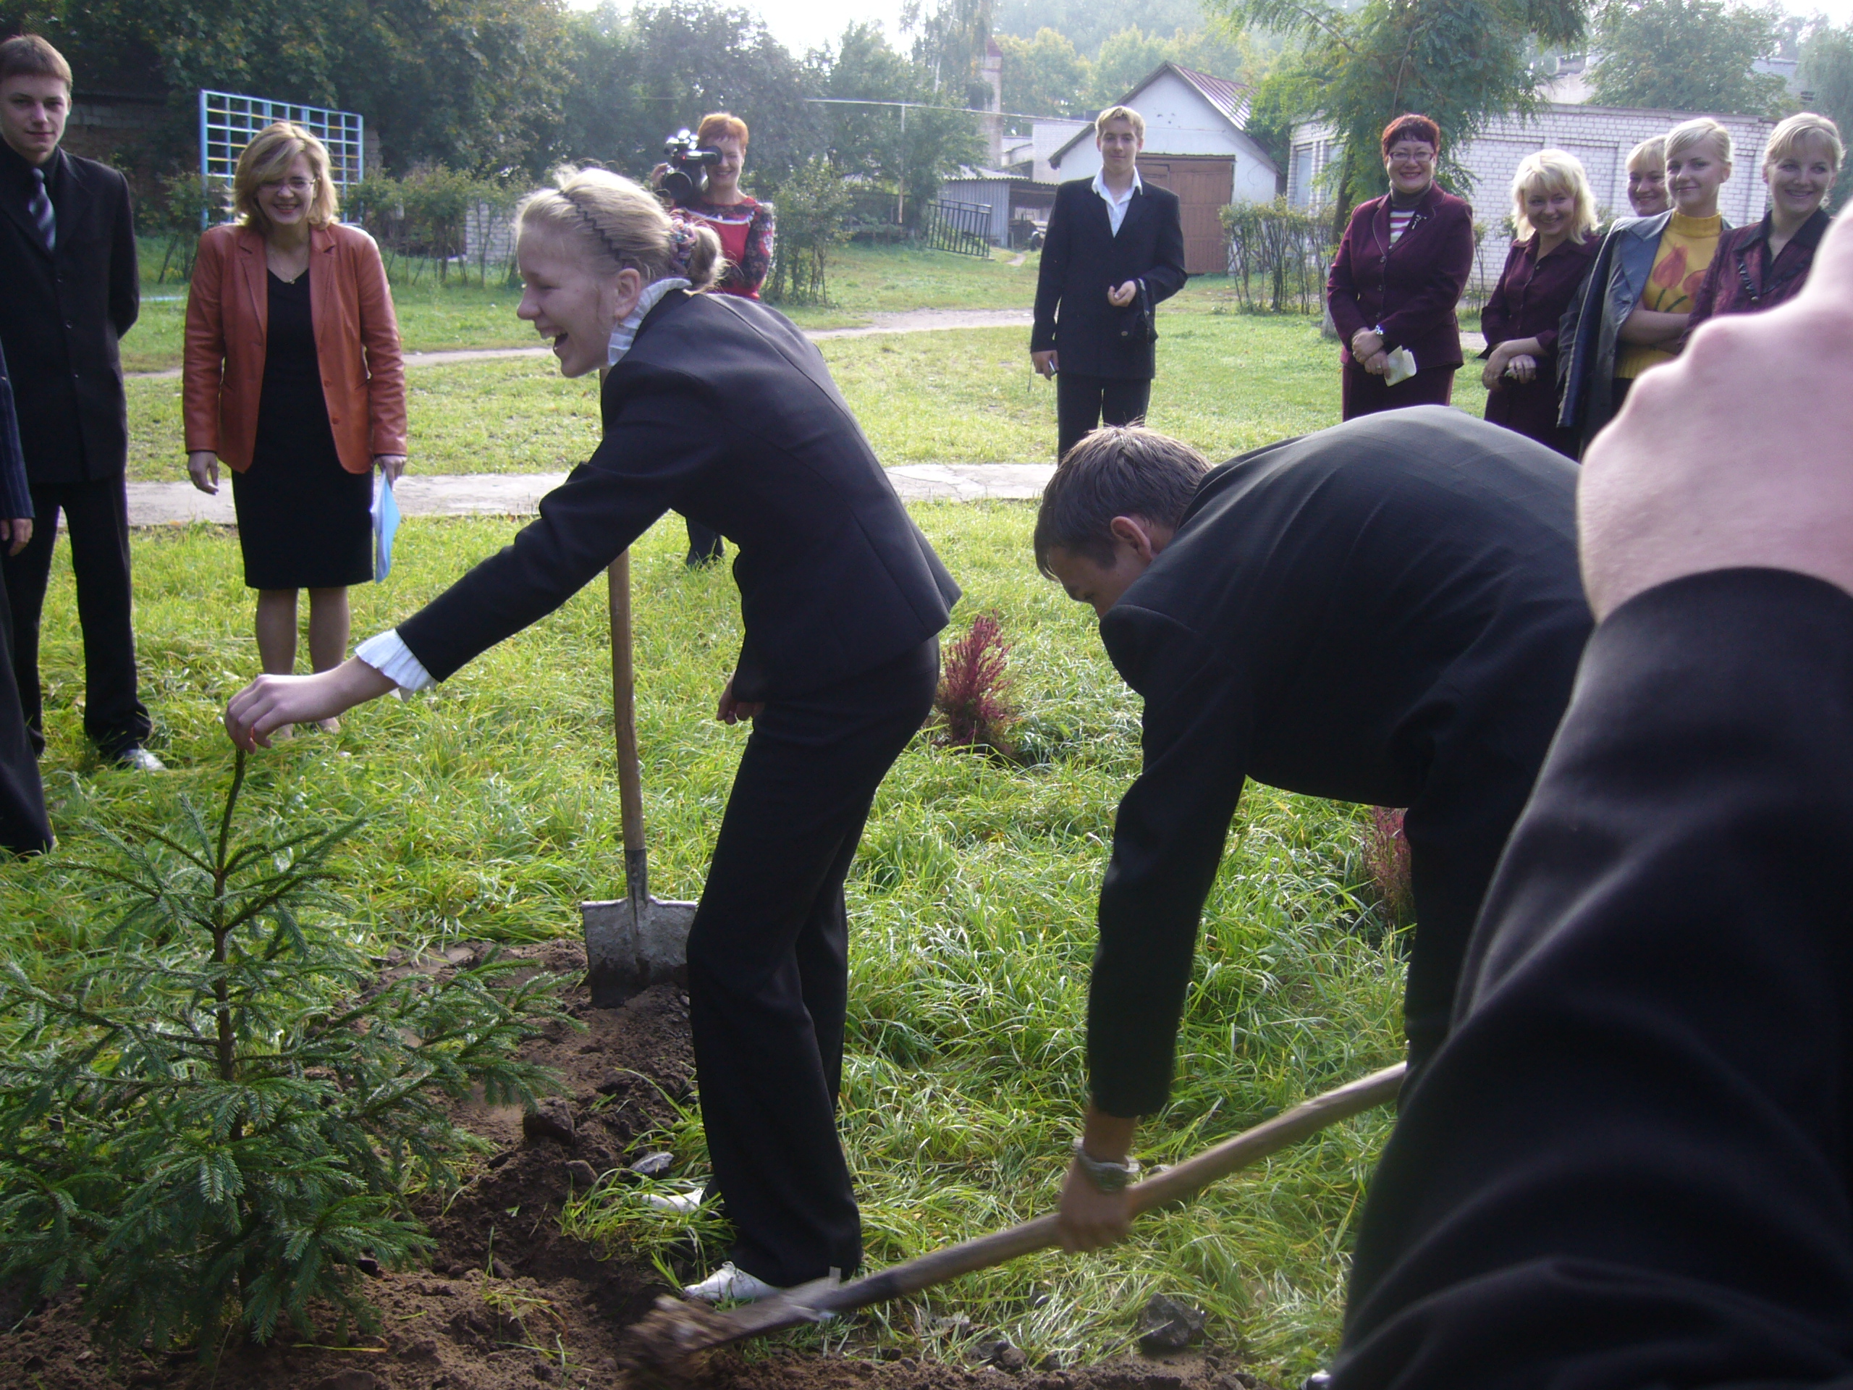
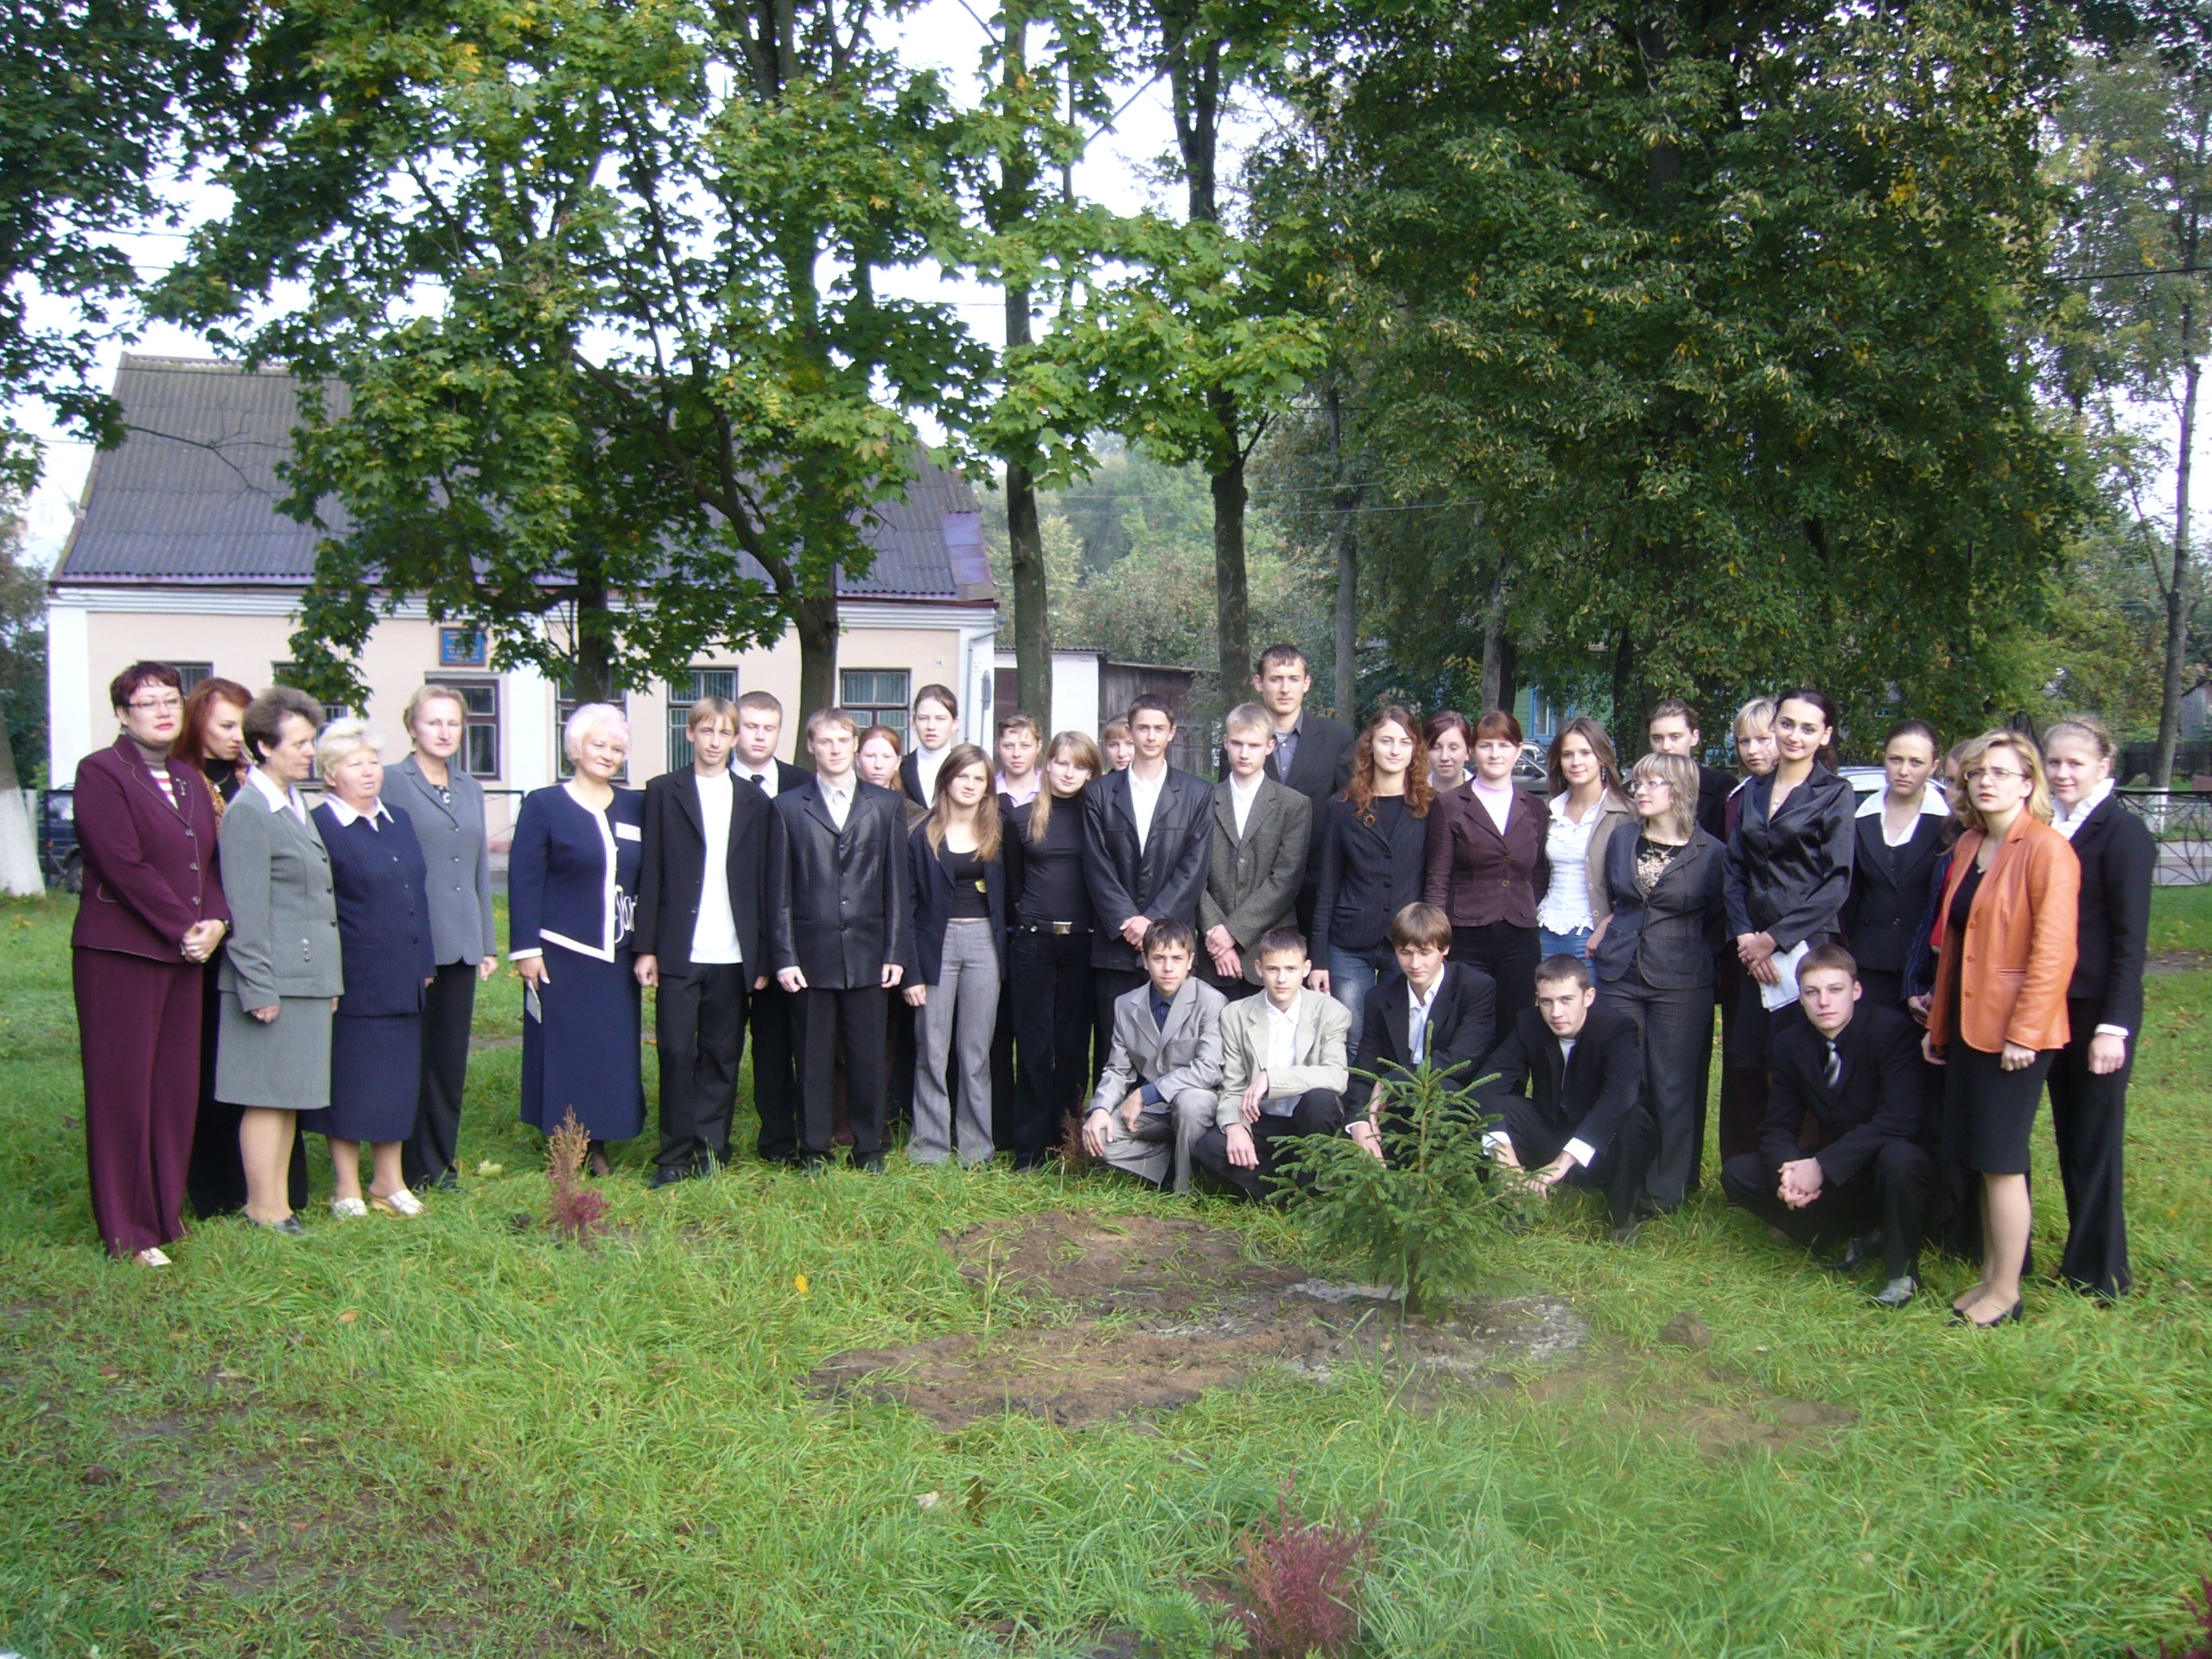
ENO TREE PLANTING DAY / 21st of September 2005
Name of school/group/individual
Gymnasium 1
City/town
Dyatlovo
Country
Belarus
Species of tree in Latin
Picea abies
Height of tree plant (as cm or mm)
125
Number of trees 1
Your comments about the event
Dear Friends!
We have done it! The first tree planned has planted! It was a fur-tree (125 sm) an ever-green tree normal for our climate.
The tree was brought beforehand, the suitable place was chosen and the hole was dig early in the morning. We decided to do it with our school-leavers, this tree is the first tree in our school-leavers alley,
so we shall plant a tree every year. We invited the administration of our school, educational authorities, teachers and parents. It was very
exciting. The pupils were too glad and too inspired especially after the letter of the Minister of education and science, the speech which was first read in English and then in our native language in translation. It
was Super! Thank you for the idea, we`ll continue to work with you next year.
Greetings from Belarus!
Gymnasium 1, Dyatlovo.

